28.86: There are two parts to the magnetic field: that from the half loop and that from the straight wire segment running from to a.
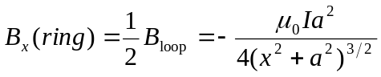
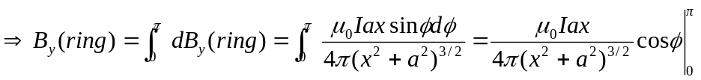
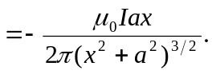
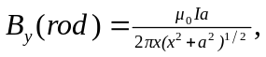 using Eq. (28.8). So the total field components are:
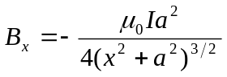
and
